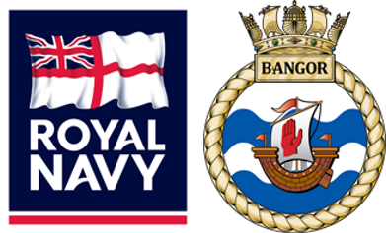
Returning to
The Gulf

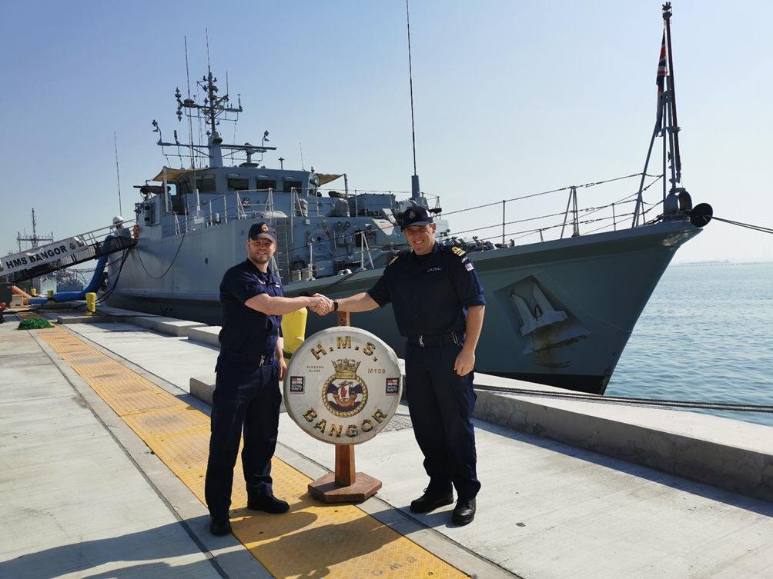
Above: (Left) Lt Cdr Joel Roberts MBE, the outbound Captain, shakes hands with (Right) Lt Cdr Rob Couzens during the handover of HMS BANGOR from Crew 6 back to Crew 8.

After 4 months of Regeneration, Crew 8 have returned to the Gulf to resume Operations with HMS BANGOR. The new crewing model allowed all members of the Ship’s Company to spend some quality time with loved ones whilst allowing for courses and administration, ready to get back to Bahrain.
After a few days alongside having completed the crew change, BANGOR sailed to conduct weapons and seamanship training in theatre, to blow away the cobwebs after several months ashore. This also started the process of qualifying new joiners to the crew, and allowing everyone to refresh key skills and drills.
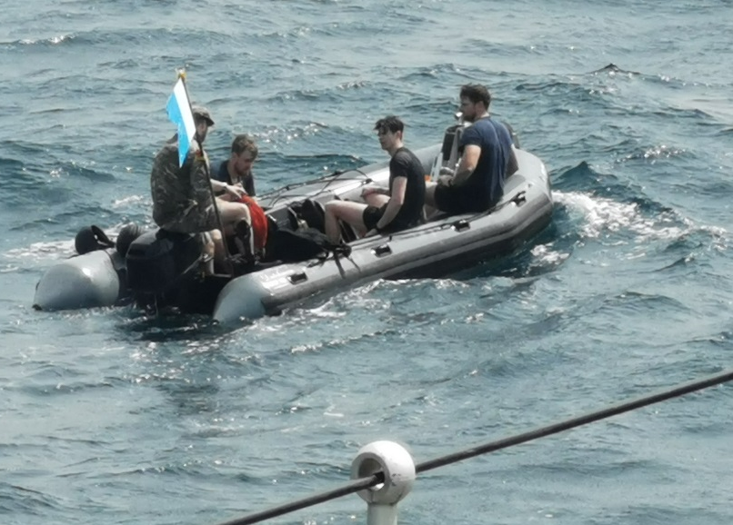
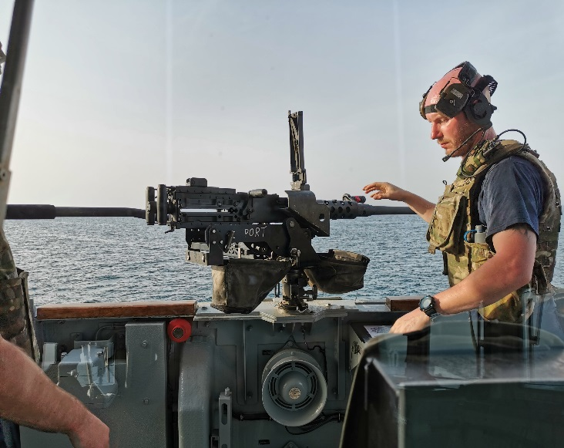
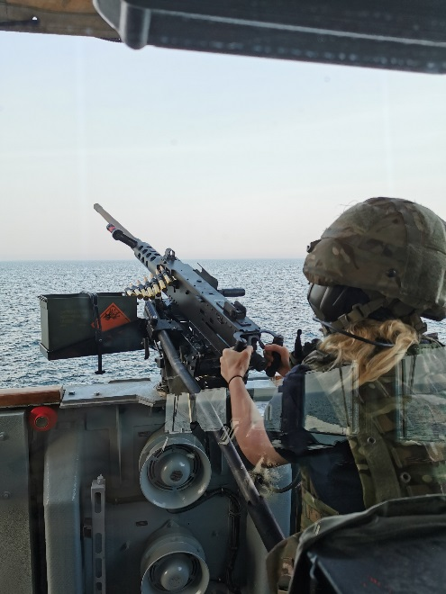
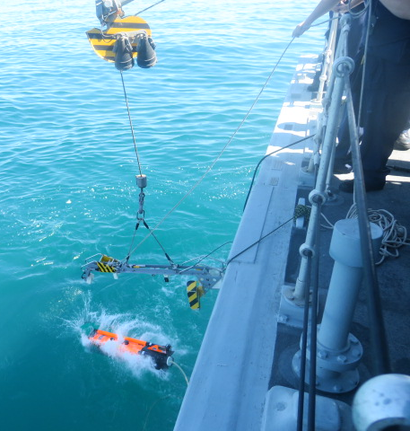
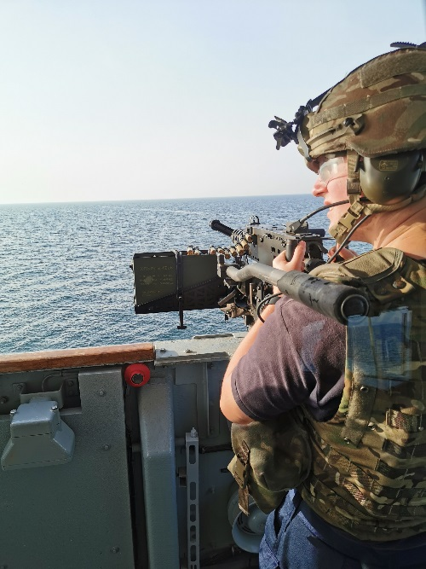
Top Left: AB (MW) Kieran Burrows prepares to engage the floating target.
Top Centre: BANGOR launches a Seafox ROV
Top Right: AB (MW) Paige Kay engages a flare target.

Below Left: BANGOR’s Divers man the Dive Boat en route to lay a Diver Placed Charge, one of the Ship’s main weapons against mines.
Below Right: LS (MW) Jonathon Dodds clears a stoppage and inspects the HMG, after overseeing the shoot.
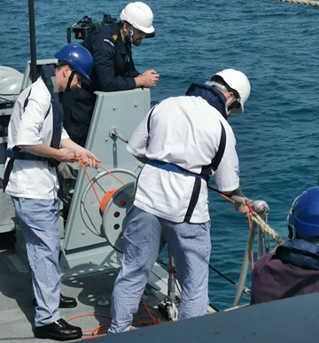
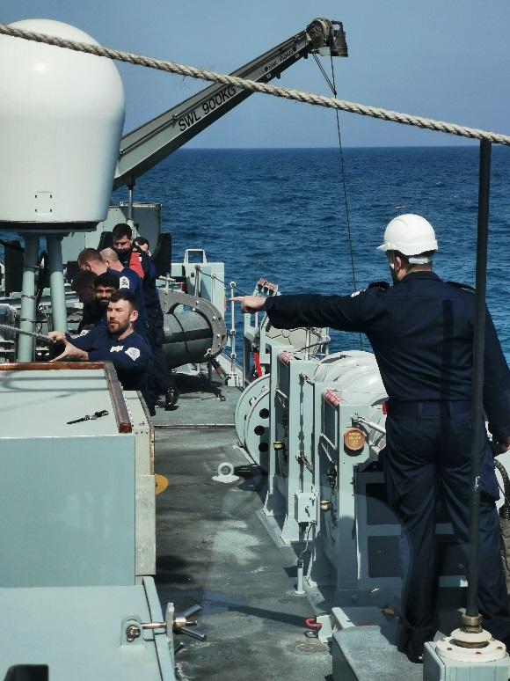
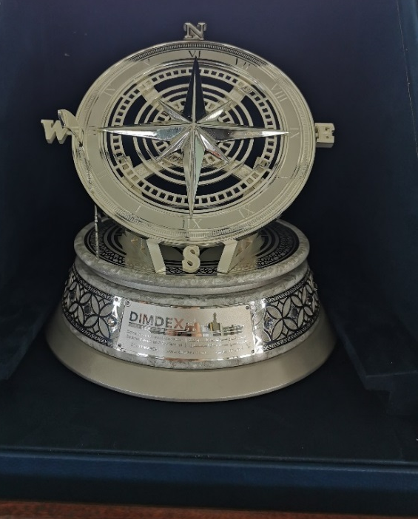
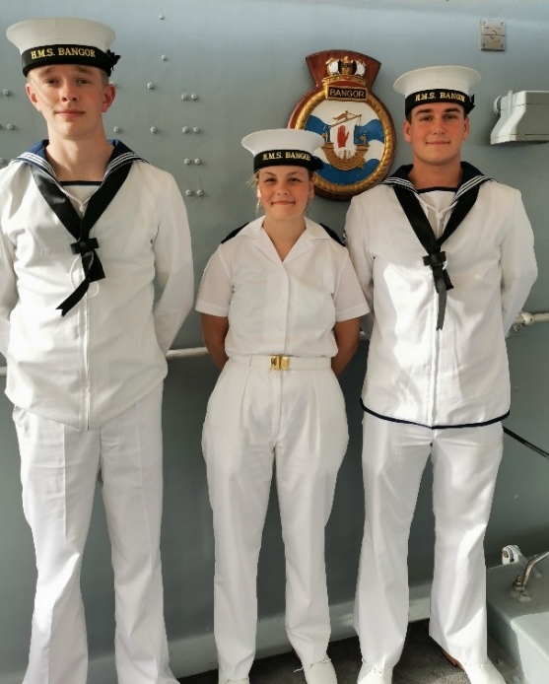
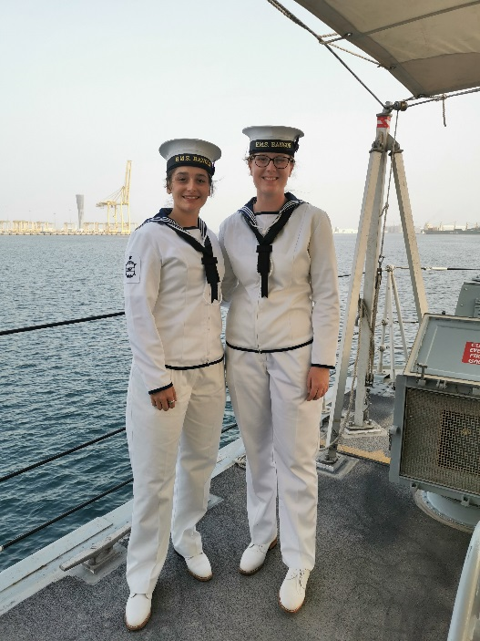
Above Left: (Left to Right) AB (MW)s Jak Rowan-Thompson, Paige Kay and Lennon Patterson during the Ship Open to Visitors event in Doha.
Above Centre: The award presented to the Ship’s Company for its valuable contribution to DIMDEX.
Above Right: AB (MW)s Lauren Stone and Beth Williams pose for a photo.

Crew 8 attended the Doha International Maritime Defence Exhibition and Conference (DIMDEX, for short!) in late March. They represented the RN and UK over several days, with the ship opened to visitors, sports matches against other nations, and all manner of other events in Qatar.

Above Left: Duty First Aiders (Left) Steward Daniel Mencarini and L (CS) Ryan Cameron prepare to treat an exercise casualty, while Bosun/ORS PO (MW) Ryan McKinney looks on.
Above Right: The Ship’s Company hauls on the swimmer recovery line to recover an exercise Man over Board.
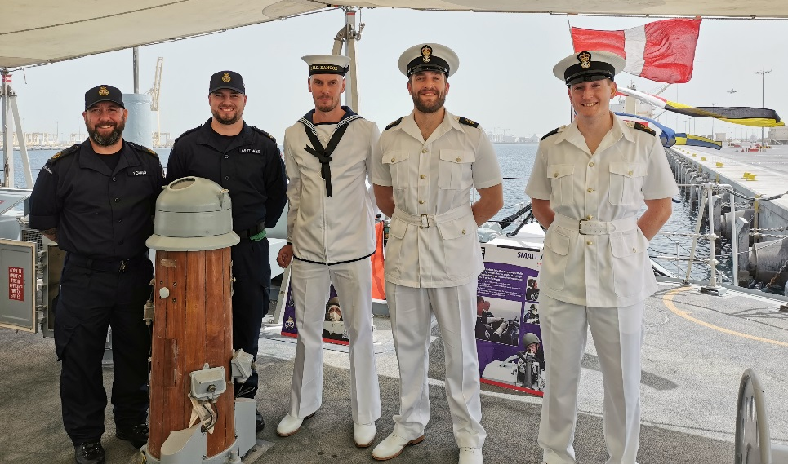


Above: (Left to Right) CPOET (WE) Lee Young, ET (WE) Lewis Whitaker, LS (MW) Lee Dodds, PO (MW) Ryan McKinney and POET (WE) Rob Bell pose for a photo during the Ship Open to Visitors event during DIMDEX 2022.
Centre: (Left to Right) Lts Simon Inkley, Chris Gray, James Sharpe and James Timmis at the opening Ceremony to DIMDEX 2022.
Bottom Left: AB (MW) Beth Williams talks a group of visitors through the finer points of the Seafox ROV.
Bottom Right: The CO exchanges gifts and talks with a delegation from the PMSS Kolachi.

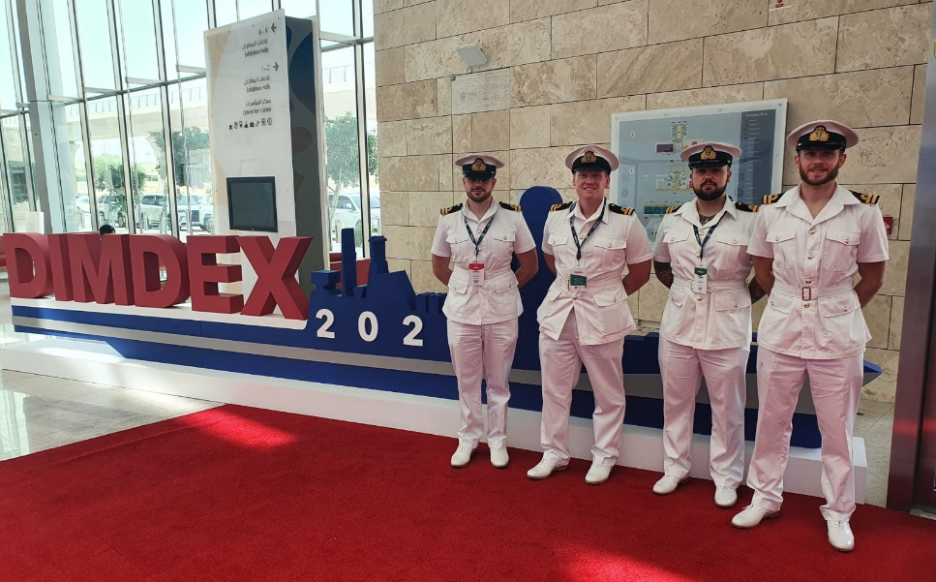

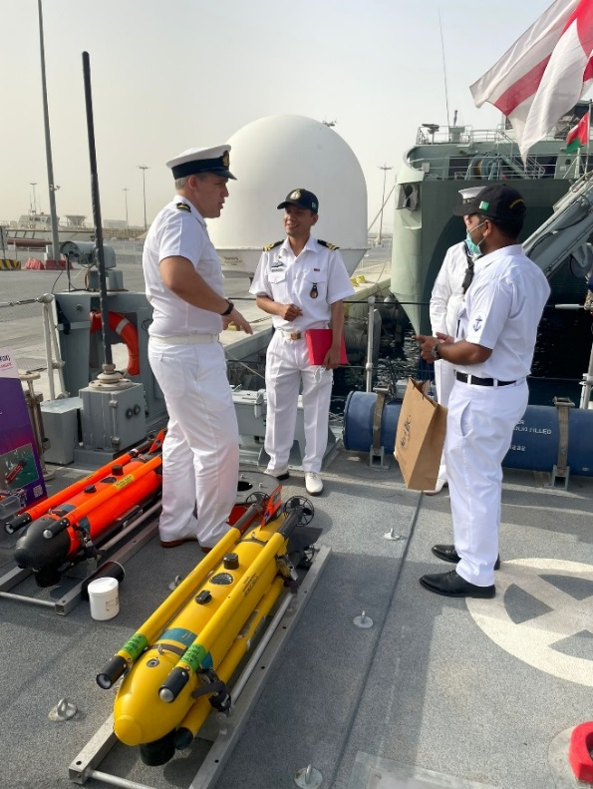
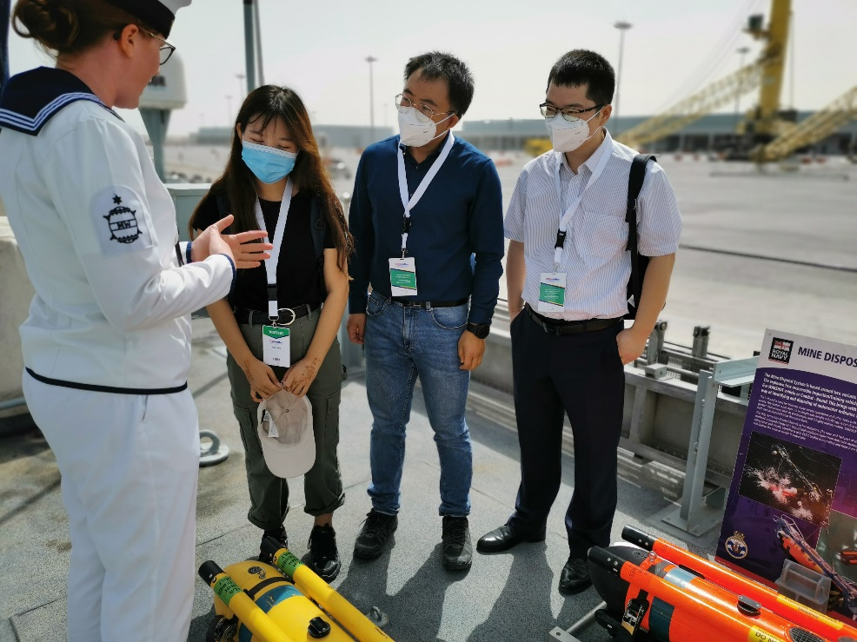
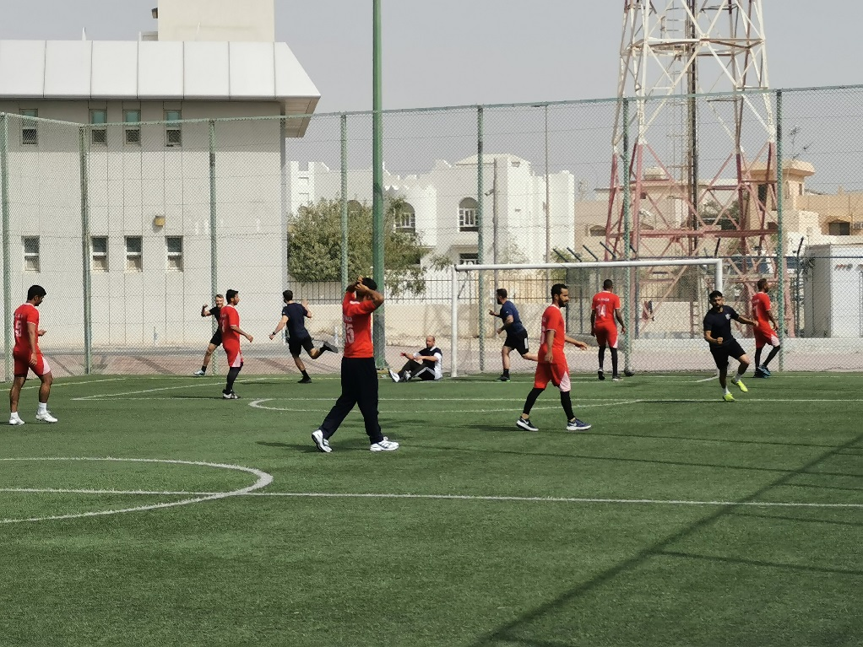
Left Top: HMS BANGOR goes 1- nil up in a game of football against the Omani Navy, ending in a 4-1 loss- characterized by good grit and very poor refereeing decisions!
Centre Left: The Tug of War team closes up for the final pull against the Indian Navy. A very strong performance with every pull won!
Bottom Left: The Tug of War team strikes a pose with their medals with (Left to Right) CPOET (WE) Lee Young and Lt Chris Gray kneeling and Leading Diver Joe Smith, Lt James Timmis. Lt James Sharpe, AB (D) Will Morrison and PO (MW) Ryan McKinney stood in the back row.

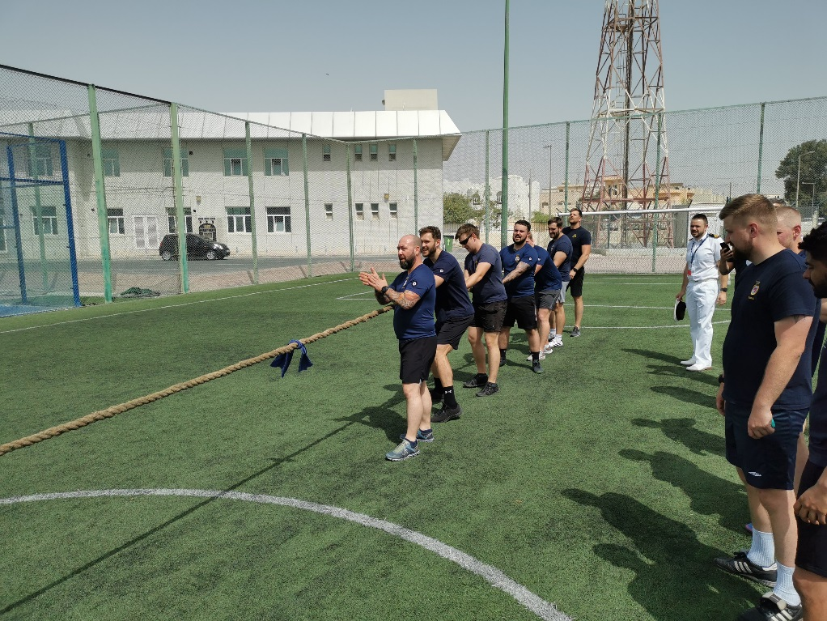
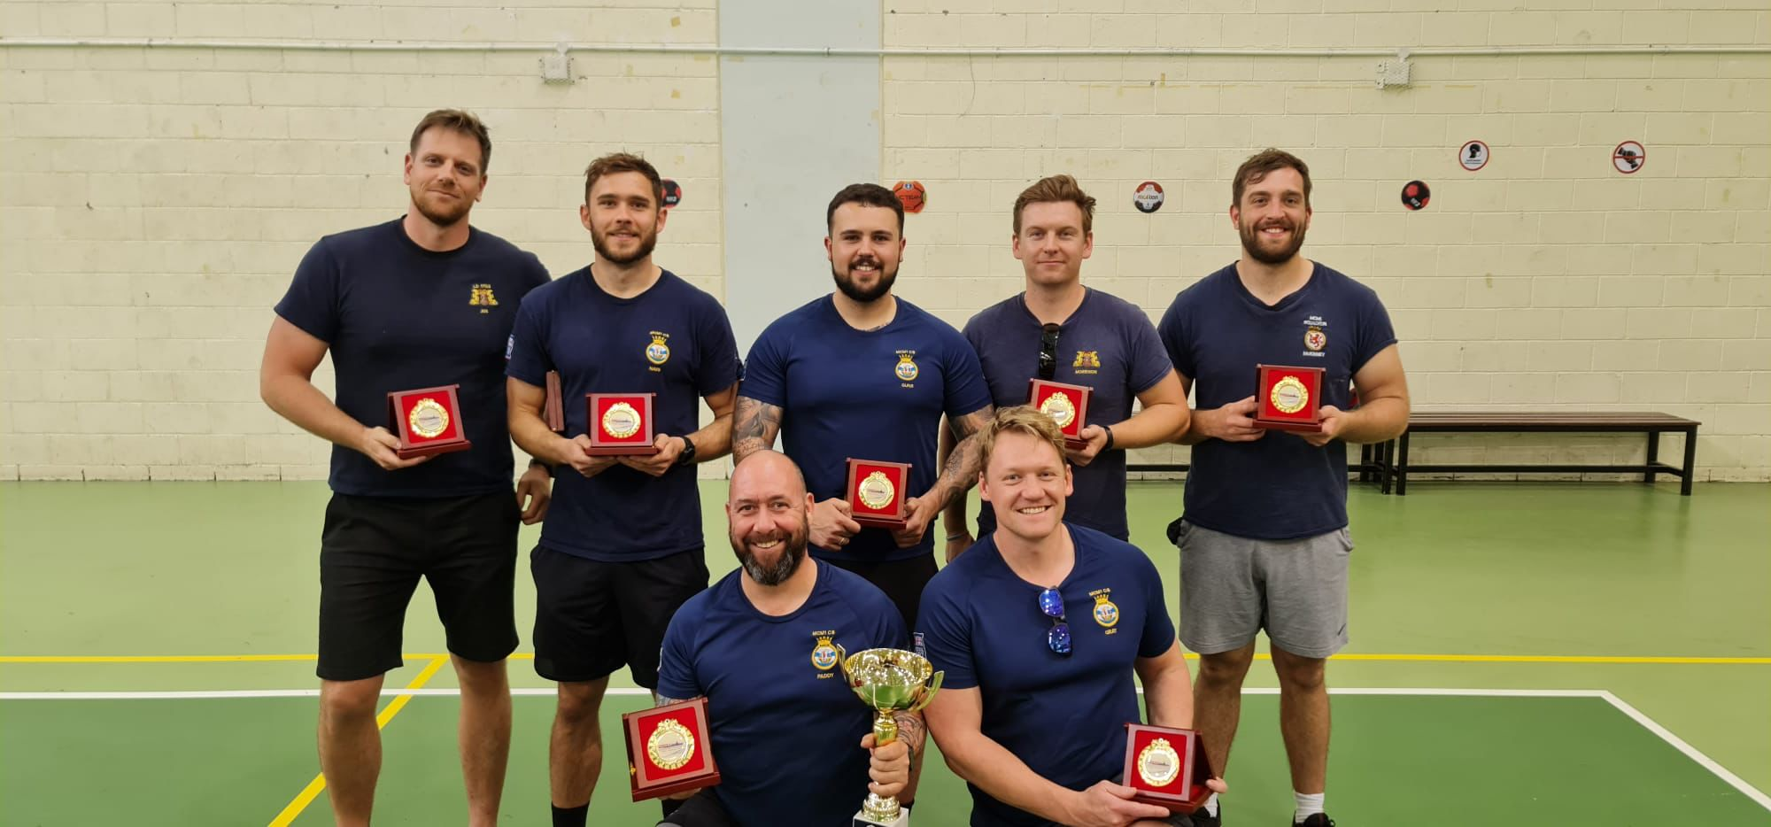
BANGOR put in a strong performance in the Sporting fixtures, winning the Tug Of War in a superb display, and coming third in the Football- starting with an utterly dominating performance over a literally nonexistent Italian team, a hard fought 4-1 loss to Oman, and a strong and convincing 4-0 victory over India.

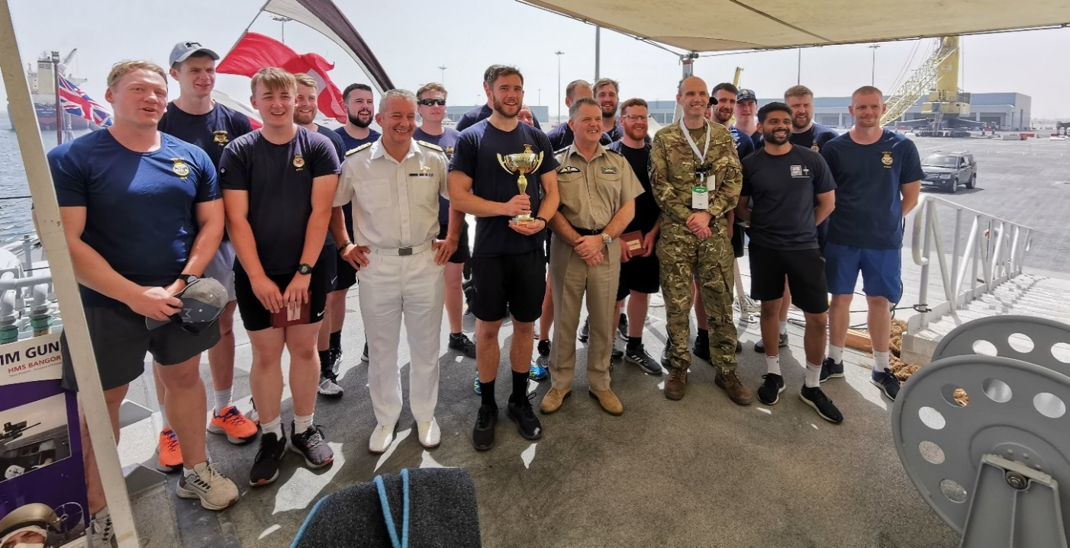

Above: The guests hosted on board pose with the victorious sports team on their return to the ship.
The same day as half of Crew 8 put in a strong performance at the DIMDEX Sport Event, the remainder of the Ship’s Company put in an equally strong effort in preparing and hosting a number of senior Royal Navy and Royal Air Force Officers. The Catering Branch did excellent work, with the junior Mine Warfare rates doing equally well as hosts.
Crew 8 also took the time to celebrate the hard work of special members of the Ship’s Company, with the Captain presenting AB (CS) Kirsty McIntosh her 15 year Long Service and Good Conduct Medal. Kirsty will soon be completing her time on the Crew, and she has been an integral part of the ship throughout her service.
Finally, the Ship’s Company would like to wish A Happy Mother’s Day to all our friends and family!

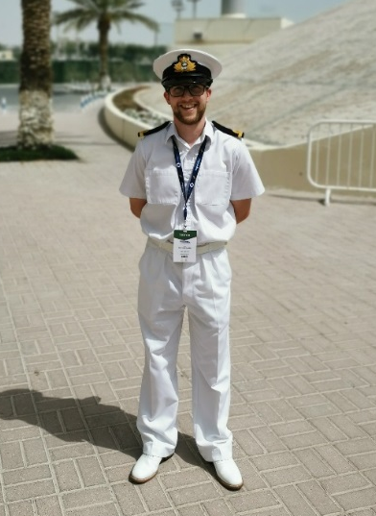
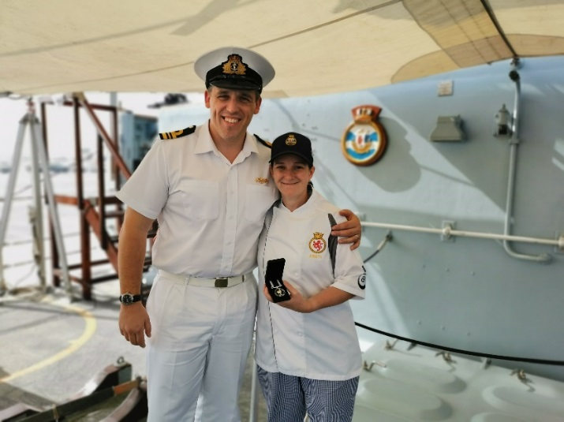
Above Left: AB (CS) Kirsty McIntosh receives her LSCG Medal from the Captain.
Above Right: The Author, SLt Matthew Harris, makes a rare appearance from behind the camera, to appease his Grandparents.

